Second Christmas

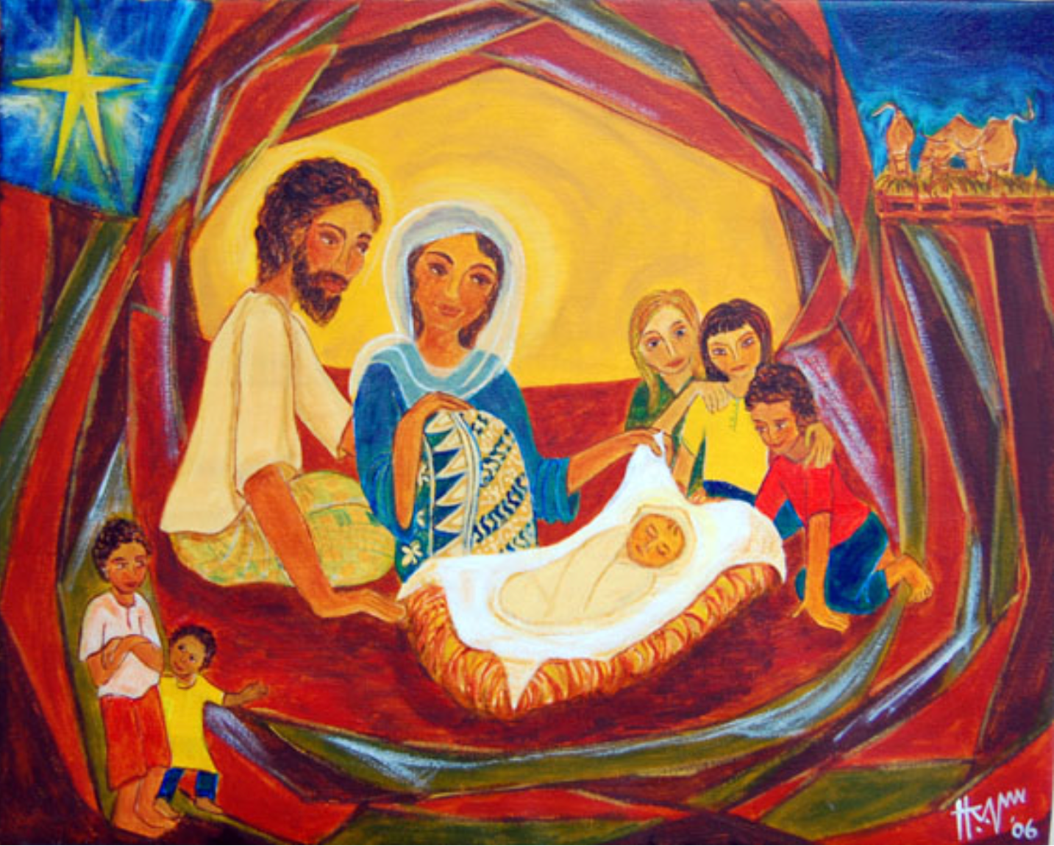

January 5, 2025 8 a.m. and 10 a.m.

Episcopal Church of the Nativity
San Rafael, California

Merry Christmas and Peace to you!

The Rev. Kirsten Snow Spalding, Rector
The Rev. Scott Sinclair, Priest in Residence
The Rev. Rebecca Morehouse, Deacon

The Word of God

Prelude O Light of Light, Love given birth (Elmhurst) by C. Ratcliff

Entrance Rite

Entrance Hymn Away in a manger, no crib for his bed (Cradle Song) (H 101)

Opening Acclamation
The people standing, the Presider says
 | Blessed be God: Father, Son, and Holy Spirit.
People | And blessed be his kingdom, now and for ever. Amen.

Collect for Purity
The Presider may say
Almighty God, to you all hearts are open, all desires known, and from you no secrets are hid: Cleanse the thoughts of our hearts by the inspiration of your Holy Spirit, that we may perfectly love you, and worthily magnify your holy Name; through Christ our Lord. Amen.

Opening Anthem or Song of Praise S 277 Glory to God (Canticle 20) (Hurd)
The following is sung, all standing

The Collect of the Day
Presider | The Lord be with you.
People | And also with you.
Presider | Let us pray.

O God, who wonderfully created, and yet more wonderfully restored, the dignity of human nature: Grant that we may share the divine life of him who humbled himself to share our humanity, your Son Jesus Christ; who lives and reigns with you, in the unity of the Holy Spirit, one God, for ever and ever. Amen.

The Lessons

First Reading: Jeremiah 31:7-14
The people sit.
A Reading from the book of the prophet Jeremiah.
⁷Thus says the Lord:
“Sing aloud with gladness for Jacob,
and raise shouts for the chief of the nations;
proclaim, give praise, and say,
‘Save, O Lord, your people,
the remnant of Israel.’
⁸See, I am going to bring them from the land of the north,
and gather them from the farthest parts of the earth,
among them the blind and the lame,
those with child and those in labor, together;
a great company, they shall return here.
⁹With weeping they shall come,
and with consolations I will lead them back,
I will let them walk by brooks of water,
in a straight path in which they shall not stumble;
for I have become a father to Israel,
and Ephraim is my firstborn.
¹⁰Hear the word of the Lord, O nations,
and declare it in the coastlands far away;
say, ‘He who scattered Israel will gather him,
and will keep him as a shepherd a flock.’
¹¹For the Lord has ransomed Jacob,
and has redeemed him from hands too strong for him.
¹²They shall come and sing aloud on the height of Zion,
and they shall be radiant over the goodness of the Lord,
over the grain, the wine, and the oil,
and over the young of the flock and the herd;
their life shall become like a watered garden,
and they shall never languish again.
¹³Then shall the young women rejoice in the dance,
and the young men and the old shall be merry.
I will turn their mourning into joy,
I will comfort them, and give them gladness for sorrow.
¹⁴I will give the priests their fill of fatness,
and my people shall be satisfied with my bounty,”
says the Lord.

Reader | The Word of the Lord.
People | Thanks be to God.

Silence may follow.

Psalm: Psalm 84
Remain seated.
¹How dear to me is your dwelling, O Lord of hosts! *
My soul has a desire and longing for the courts of the Lord;
my heart and my flesh rejoice in the living God.
²The sparrow has found her a house
and the swallow a nest where she may lay her young; *
by the side of your altars, O Lord of hosts,
my King and my God.
³Happy are they who dwell in your house! *
they will always be praising you.
⁴Happy are the people whose strength is in you! *
whose hearts are set on the pilgrims’ way.
⁵Those who go through the desolate valley will find it a place of springs, *
for the early rains have covered it with pools of water.
⁶They will climb from height to height, *
and the God of gods will reveal himself in Zion.
⁷Lord God of hosts, hear my prayer; *
hearken, O God of Jacob.
⁸Behold our defender, O God; *
and look upon the face of your Anointed.
⁹For one day in your courts is better than a thousand in my own room, *
and to stand at the threshold of the house of my God
than to dwell in the tents of the wicked.
¹⁰For the Lord God is both sun and shield; *
he will give grace and glory;
¹¹No good thing will the Lord withhold *
from those who walk with integrity.
¹²O Lord of hosts, *
happy are they who put their trust in you!

Second Reading: Ephesians 1:3-6, 15-19a
The people sit.
A Reading from Paul's letter to the Church in Ephesus.
³Blessed be the God and Father of our Lord Jesus Christ, who has blessed us in Christ with every spiritual blessing in the heavenly places, ⁴just as he chose us in Christ before the foundation of the world to be holy and blameless before him in love. ⁵He destined us for adoption as his children through Jesus Christ, according to the good pleasure of his will, ⁶to the praise of his glorious grace that he freely bestowed on us in the Beloved.
¹⁵I have heard of your faith in the Lord Jesus and your love toward all the saints, and for this reason ¹⁶I do not cease to give thanks for you as I remember you in my prayers. ¹⁷I pray that the God of our Lord Jesus Christ, the Father of glory, may give you a spirit of wisdom and revelation as you come to know him, ¹⁸so that, with the eyes of your heart enlightened, you may know what is the hope to which he has called you, what are the riches of his glorious inheritance among the saints, ^{19a}and what is the immeasurable greatness of his power for us who believe.

Reader | The Word of the Lord.
People | Thanks be to God.

Silence may follow.

Sequence Hymn Of the Father's love begotten (Divinum mysterium) (H 82)
All stand.
Gospel: Matthew 2:13-15, 19-23
All stand.
Deacon | The Holy Gospel of our Lord Jesus Christ according to Matthew.
People | Glory to you, Lord Christ.

¹³After the wise men had left, an angel of the Lord appeared to Joseph in a dream and said, “Get up, take the child and his mother, and flee to Egypt, and remain there until I tell you; for Herod is about to search for the child, to destroy him.” ¹⁴Then Joseph got up, took the child and his mother by night, and went to Egypt, ¹⁵and remained there until the death of Herod. This was to fulfill what had been spoken by the Lord through the prophet, “Out of Egypt I have called my son.”
¹⁹When Herod died, an angel of the Lord suddenly appeared in a dream to Joseph in Egypt and said, ²⁰“Get up, take the child and his mother, and go to the land of Israel, for those who were seeking the child’s life are dead.” ²¹Then Joseph got up, took the child and his mother, and went to the land of Israel. ²²But when he heard that Archelaus was ruling over Judea in place of his father Herod, he was afraid to go there. And after being warned in a dream, he went away to the district of Galilee. ²³There he made his home in a town called Nazareth, so that what had been spoken through the prophets might be fulfilled, “He will be called a Nazorean.”

Deacon | The Gospel of the Lord.
People | Praise to you, Lord Christ.

The Sermon The Very Rev. Kirsten Snow Spalding

The Creed
All stand.
We believe in one God,
the Father, the Almighty,
maker of heaven and earth,
of all that is, seen and unseen.
We believe in one Lord, Jesus Christ,
the only Son of God,
eternally begotten of the Father,
God from God, Light from Light,
true God from true God,
begotten, not made,
of one Being with the Father.
Through him all things were made.
For us and for our salvation
he came down from heaven:
by the power of the Holy Spirit
he became incarnate from the Virgin Mary,
and was made man.
For our sake he was crucified under Pontius Pilate;
he suffered death and was buried.
On the third day he rose again
in accordance with the Scriptures;
he ascended into heaven
and is seated at the right hand of the Father.
He will come again in glory to judge the living and the dead,
and his kingdom will have no end.
We believe in the Holy Spirit, the Lord, the giver of life,
who proceeds from the Father and the Son.
With the Father and the Son he is worshiped and glorified.
He has spoken through the Prophets.
We believe in one holy catholic and apostolic Church.
We acknowledge one baptism for the forgiveness of sins.
We look for the resurrection of the dead,
and the life of the world to come. Amen.

The Prayers of the People
All remain standing.
With all our heart and with all our mind, let us pray to the Lord, saying, “Lord, have mercy.”
For the peace of the world, for the welfare of the holy Church of God, and for the unity of all peoples, let us pray to the Lord.
Lord, have mercy.
For our Bishop Sean, our Diocesan Bishop Austin, our Nativity clergy, Kirsten, Scott and Rebecca and for all the clergy and people, let us pray to the Lord.
Lord, have mercy.

For our President Joe, for the leaders of the nations, and for all in authority, let us pray to the Lord.
Lord, have mercy.

For this city of San Rafael, for every city and community, and for those who live in them, let us pray to the Lord.
Lord, have mercy.

For the good earth which God has given us, and for the wisdom and will to conserve it, let us pray to the Lord.
Lord, have mercy.

For those who travel on land, on water, or in the air [or through outer space], let us pray to the Lord.
Lord, have mercy.

For the aged and infirm, for the widowed and orphans, and for the sick and the suffering, let us pray to the Lord.
Lord, have mercy.

For our parish members Jamie, Nancy B, Nina A, Marian, Norma, Duane, Amanda, Ruth, Steve K, Dick, Barbara B, and Uwe; and our family and friends, Miles, David, John, Violet & John, B. Y., Justin, John B, Laura, Tanner, Lisa, Phil, Greg, Nick and Phoebe, let us pray to the Lord.
Lord, have mercy.

For the poor and the oppressed, for the unemployed and the destitute, for prisoners and captives, and for all who remember and care for them, let us pray to the Lord.
Lord, have mercy.

For all who have died in the hope of the resurrection, remembering especially Bill Shepherd and Fr. Michael Hiller and for all the departed, let us pray to the Lord.
Lord, have mercy.

For deliverance from all danger, violence, oppression, and degradation, let us pray to the Lord.
Lord, have mercy.

For the absolution and remission of our sins and offenses, let us pray to the Lord.
Lord, have mercy.

That we may end our lives in faith and hope, without suffering and without reproach, let us pray to the Lord.
Lord, have mercy.
In the communion of Mary and Joseph and of all the saints, let us commend ourselves, and one another, and all our life, to Christ our God.
To thee, O Lord our God.
Silence
The Presider adds a concluding Collect.

The Peace
All stand.
Presider | The peace of the Lord be always with you.
People | And also with you.

Then the Ministers and the People may greet one another in the name of the Lord.

Announcements

Join us for Epiphany Prayers tomorrow January 6th at 5 p.m. A time of candlelit contemplation followed by Evening Prayer with the story of the coming of the Magi (Mt. 2:1-12). Co-hosted by Nativity and St. Paul’s.

Street Chaplaincy. Nativity will lead the cooking of the Tuesday night Wellness Gathering meal for our neighbors who live outside. January 7th 4:30-7 p.m. at First Presbyterian Church San Rafael. Email Rev. Kirsten for details at nativityonthehill@gmail.com.

The Holy Communion

Offertory Sentence
The Presider says
Offer to God a sacrifice of thanksgiving, and make good your vows to the Most High. Psalm 50:14

Offertory Hymn What star is this, with beams so bright (Puer nobis) (H 124)
The Great Thanksgiving

Sursum Corda
The People remain standing.
Presider | The Lord be with you.
People | And also with you.
Presider | Lift up your hearts.
People | We lift them to the Lord.
Presider | Let us give thanks to the Lord our God.
People | It is right to give him thanks and praise.

Proper Preface
Facing the Holy Table, the Presider proceeds
It is right, and a good and joyful thing, always and everywhere to give thanks to you, Father Almighty, Creator of heaven and earth.
Because you gave Jesus Christ, your only Son, to be born for us; who, by the mighty power of the Holy Spirit, was made perfect Man of the flesh of the Virgin Mary his mother; so that we might be delivered from the bondage of sin, and receive power to become your children.
Therefore we praise you, joining our voices with Angels and Archangels and with all the company of heaven, who for ever sing this hymn to proclaim the glory of your Name:

Sanctus
Presider and People
Holy, holy, holy Lord, God of power and might,
heaven and earth are full of your glory.
Hosanna in the highest.
Blessed is he who comes in the name of the Lord.
Hosanna in the highest.

Words of Institution
The People stand or kneel.
The Presider continues
Holy and gracious Father: In your infinite love you made us for yourself; and, when we had fallen into sin and become subject to evil and death, you, in your mercy, sent Jesus Christ, your only and eternal Son, to share our human nature, to live and die as one of us, to reconcile us to you, the God and Father of all.
He stretched out his arms upon the cross, and offered himself in obedience to your will, a perfect sacrifice for the whole world.
On the night he was handed over to suffering and death, our Lord Jesus Christ took bread; and when he had given thanks to you, he broke it, and gave it to his disciples, and said, “Take, eat: This is my Body, which is given for you. Do this for the remembrance of me.”
After supper he took the cup of wine; and when he had given thanks, he gave it to them, and said, “Drink this, all of you: This is my Blood of the new Covenant, which is shed for you and for many for the forgiveness of sins. Whenever you drink it, do this for the remembrance of me.”
Therefore we proclaim the mystery of faith:
Presider and People
Christ has died.
Christ is risen.
Christ will come again.

Epiclesis
The Presider continues
We celebrate the memorial of our redemption, O Father, in this sacrifice of praise and thanksgiving. Recalling his death, resurrection, and ascension, we offer you these gifts.
Sanctify them by your Holy Spirit to be for your people the Body and Blood of your Son, the holy food and drink of new and unending life in him. Sanctify us also that we may faithfully receive this holy Sacrament, and serve you in unity, constancy, and peace; and at the last day bring us with all your saints into the joy of your eternal kingdom.
All this we ask through your Son Jesus Christ. By him, and with him, and in him, in the unity of the Holy Spirit all honor and glory is yours, Almighty Father, now and for ever. AMEN.

The Lord’s Prayer
As our Savior Christ has taught us, we now pray,
People and Presider
Our Father in heaven,
hallowed be your Name,
your kingdom come,
your will be done, on earth as in heaven.
Give us today our daily bread.
Forgive us our sins
as we forgive those who sin against us.
Save us from the time of trial
and deliver us from evil.
For the kingdom, the power,
and the glory are yours,
now and forever. Amen.

The Breaking of the Bread

Fraction Anthem Love came down at Christmas (Gartan) (H 84)
Invitation
The Presider says
The Gifts of God for the People of God.

Distribution
All God’s people are invited to participate in Holy Communion. If you do not wish to receive bread and wine, you may come forward with hands crossed at your chest and the priest will offer a blessing.
The Bread and the Cup are given to the communicants with these words
The Body of Christ, the bread of heaven. [Amen.]
The Blood of Christ, the cup of salvation. [Amen.]

Communion Hymn Let all mortal flesh keep silence (Picardy) (H 324)

Post-Communion Prayer
After Communion, the Presider says
Let us pray.
Presider and People
Eternal God, heavenly Father,
you have graciously accepted us as living members
of your Son our Savior Jesus Christ,
and you have fed us with spiritual food
in the Sacrament of his Body and Blood.
Send us now into the world in peace,
and grant us strength and courage
to love and serve you
with gladness and singleness of heart;
through Christ our Lord. Amen.

Christmas Blessing
May Christ, who by his Incarnation gathered into one things earthly and heavenly, fill you with his joy and peace; and the blessing of God Almighty, the Father, the Son and the Holy Spirit, be among you and remain with you always. Amen.

Post-Communion Hymn When Jesus left his Father's throne (Kingsfold) (H 480)
Dismissal
 | Let us go forth in the name of Christ.
People | Thanks be to God.

Postlude Where is this stupendous stranger? (Mariposa) by C Susa

From riteplanning.com.
Copyright © 2025 Church Publishing Inc. All rights reserved.

