Candlelight Christmas Eve

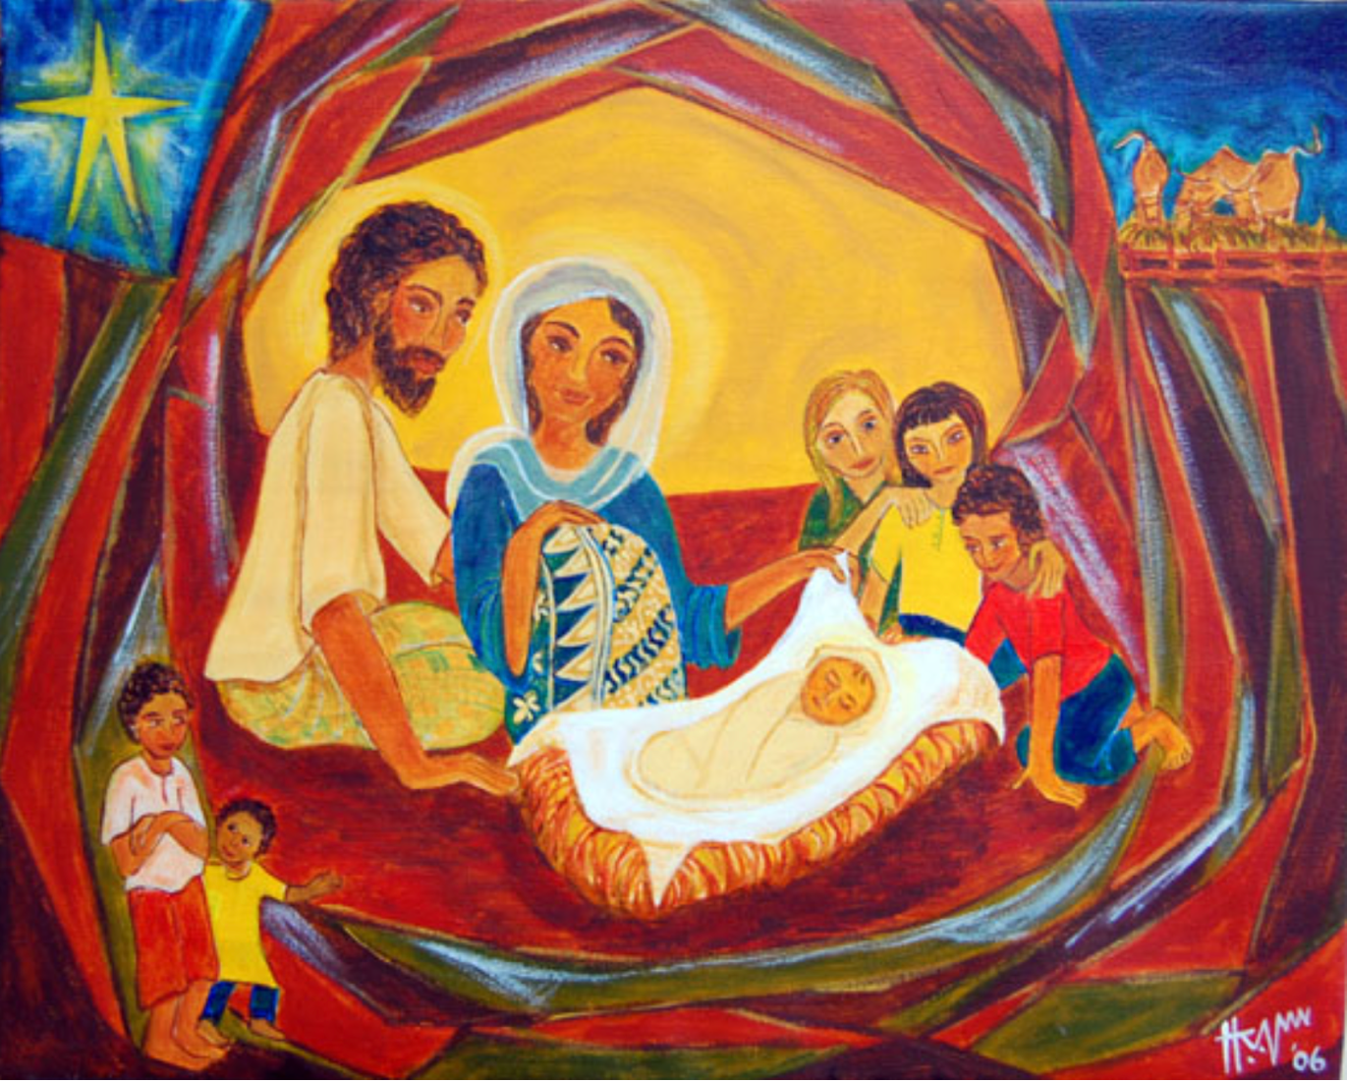

December 24, 2024, 5 p.m.

Episcopal Church of the Nativity
San Rafael, California
www.nativityonthehill.org

Merry Christmas and Peace to you!

The Very Rev. Kirsten Snow Spalding, Rector
The Rev. Scott Sinclair, Priest in Residence
The Rev. Lynn Oldham Robinett, Assisting Priest
The Rev. Rebecca Morehouse, Deacon

Our service this evening begins in the candlelit church. We invite you to gather with us in quiet contemplation. If you are joining us on Facebook live, begin by lighting your own candles and coming together for a moment of silent prayer.

Festival Choir A Christmas Carol by Charles Ives
Choir is led by our music director Fred Goff with AJ Johnson, mezzo soprano soloist.

The Word of God

Entrance Hymn O come, all ye faithful (Adeste fideles) (H 83 v 1-3, 6)
Opening Acclamation
The people standing, the Presider says
 | Blessed be God: Father, Son, and Holy Spirit.
People | And blessed be God's reign, now and for ever. Amen.

Collect for Purity
The Presider may say
Almighty God, to you all hearts are open, all desires known, and from you no secrets are hid: Cleanse the thoughts of our hearts by the inspiration of your Holy Spirit, that we may perfectly love you, and worthily magnify your holy Name; through Christ our Lord. Amen.

Song of Praise Angels, from the realms of glory H 93

The Collect of the Day
Presider | The Lord be with you.
People | And also with you.
Presider | Let us pray.

O God, you have caused this holy night to shine with the brightness of the true Light: Grant that we, who have known the mystery of that Light on earth, may also enjoy him perfectly in heaven; where with you and the Holy Spirit he lives and reigns, one God, in glory everlasting. Amen.
The Lessons

First Reading: Isaiah 9:2-7
The people sit.
A Reading from the book of the prophet Isaiah.
²The people who walked in darkness
have seen a great light;
those who lived in a land of deep darkness—
on them light has shined.
³You have multiplied the nation,
you have increased its joy;
they rejoice before you
as with joy at the harvest,
as people exult when dividing plunder.
⁴For the yoke of their burden,
and the bar across their shoulders,
the rod of their oppressor,
you have broken as on the day of Midian.
⁵For all the boots of the tramping warriors
and all the garments rolled in blood
shall be burned as fuel for the fire.
⁶For a child has been born for us,
a son given to us;
authority rests upon his shoulders;
and he is named
Wonderful Counselor, Mighty God,
Everlasting Father, Prince of Peace.
⁷His authority shall grow continually,
and there shall be endless peace
for the throne of David and his kingdom.
He will establish and uphold it
with justice and with righteousness
from this time onward and forevermore.
The zeal of the Lord of hosts will do this.

Reader | Here ends the Reading.

Silence may follow. Remain seated.
Psalm: Psalm 96
¹Sing to the Lord a new song; *
sing to the Lord, all the whole earth.
²Sing to the Lord and bless his Name; *
proclaim the good news of his salvation from day to day.
³Declare his glory among the nations *
and his wonders among all peoples.
⁴For great is the Lord and greatly to be praised; *
he is more to be feared than all gods.
⁵As for all the gods of the nations, they are but idols; *
but it is the Lord who made the heavens.
⁶Oh, the majesty and magnificence of his presence! *
Oh, the power and the splendor of his sanctuary!
⁷Ascribe to the Lord, you families of the peoples; *
ascribe to the Lord honor and power.
⁸Ascribe to the Lord the honor due his Name; *
bring offerings and come into his courts.
⁹Worship the Lord in the beauty of holiness; *
let the whole earth tremble before him.
¹⁰Tell it out among the nations: “The Lord is King! *
He has made the world so firm that it cannot be moved;
he will judge the peoples with equity.”
¹¹Let the heavens rejoice, and let the earth be glad;
let the sea thunder and all that is in it; *
let the field be joyful and all that is therein.
¹²Then shall all the trees of the wood shout for joy
before the Lord when he comes, *
when he comes to judge the earth.
¹³He will judge the world with righteousness *
and the peoples with his truth.

Second Reading: Titus 2:11-14
The people sit.
A Reading from Paul's letter to Titus.
¹¹The grace of God has appeared, bringing salvation to all, ¹²training us to renounce impiety and worldly passions, and in the present age to live lives that are self-controlled, upright, and godly, ¹³while we wait for the blessed hope and the manifestation of the glory of our great God and Savior, Jesus Christ. ¹⁴He it is who gave himself for us that he might redeem us from all iniquity and purify for himself a people of his own who are zealous for good deeds.

Reader | The Word of the Lord.
People | Thanks be to God.
Silence may follow. All stand.
Sequence Hymn O little town of Bethlehem (H 78, v 1-3, 5)

Gospel: Luke 2:1-14 [15-20]
All stand.
Deacon | The Holy Gospel of our Lord Jesus Christ according to Luke.
People | Glory to you, Lord Christ.

¹In those days a decree went out from Emperor Augustus that all the world should be registered. ²This was the first registration and was taken while Quirinius was governor of Syria. ³All went to their own towns to be registered. ⁴Joseph also went from the town of Nazareth in Galilee to Judea, to the city of David called Bethlehem, because he was descended from the house and family of David. ⁵He went to be registered with Mary, to whom he was engaged and who was expecting a child. ⁶While they were there, the time came for her to deliver her child. ⁷And she gave birth to her firstborn son and wrapped him in bands of cloth, and laid him in a manger, because there was no place for them in the inn.
⁸In that region there were shepherds living in the fields, keeping watch over their flock by night. ⁹Then an angel of the Lord stood before them, and the glory of the Lord shone around them, and they were terrified. ¹⁰But the angel said to them, “Do not be afraid; for see—I am bringing you good news of great joy for all the people: ¹¹to you is born this day in the city of David a Savior, who is the Messiah, the Lord. ¹²This will be a sign for you: you will find a child wrapped in bands of cloth and lying in a manger.” ¹³And suddenly there was with the angel a multitude of the heavenly host, praising God and saying,
¹⁴“Glory to God in the highest heaven,
and on earth peace among those whom he favors!”
¹⁵When the angels had left them and gone into heaven, the shepherds said to one another, “Let us go now to Bethlehem and see this thing that has taken place, which the Lord has made known to us.” ¹⁶So they went with haste and found Mary and Joseph, and the child lying in the manger. ¹⁷When they saw this, they made known what had been told them about this child; ¹⁸and all who heard it were amazed at what the shepherds told them. ¹⁹But Mary treasured all these words and pondered them in her heart. ²⁰The shepherds returned, glorifying and praising God for all they had heard and seen, as it had been told them.

Deacon | The Gospel of the Lord.
People | Praise to you, Lord Christ.

HOMILY The Very Rev. Kirsten Snow Spalding

The Creed
We believe in one God,
the Father, the Almighty,
maker of heaven and earth,
of all that is, seen and unseen.
We believe in one Lord, Jesus Christ,
the only Son of God,
eternally begotten of the Father,
God from God, Light from Light,
true God from true God,
begotten, not made,
of one Being with the Father.
Through him all things were made.
For us and for our salvation
he came down from heaven:
by the power of the Holy Spirit
he became incarnate from the Virgin Mary,
and was made man.
For our sake he was crucified under Pontius Pilate;
he suffered death and was buried.
On the third day he rose again
in accordance with the Scriptures;
he ascended into heaven
and is seated at the right hand of the Father.
He will come again in glory to judge the living and the dead,
and his kingdom will have no end.
We believe in the Holy Spirit, the Lord, the giver of life,
who proceeds from the Father and the Son.
With the Father and the Son he is worshiped and glorified.
He has spoken through the Prophets.
We believe in one holy catholic and apostolic Church.
We acknowledge one baptism for the forgiveness of sins.
We look for the resurrection of the dead,
and the life of the world to come. Amen.

Prayers of the People
Rejoicing in God’s gift of gentle grace, let us pray for the church, the world, and all on whom the light of Christ shines.

Silence
Wonderful Counselor, you increase our joy as the church gathers on this holy night to sing of your presence among us. May the story of salvation live in the hearts of all who sing its wonders. God of light,
Hear our prayer.

Mighty God, you broke the yoke of sin’s burden through the birth of your Son. Comfort those whose burdens distract them from the deeper peace of this holy night and grant them a restful mind. God of light,
Hear our prayer.

Everlasting Father, uphold all who are in sorrow or in need of your divine goodness and mercy, especially our members: Jamie, Nancy B, Nina A, Marian, Norma, Duane, Amanda, Ruth, Steve K, Dick, Barbara B, and Uwe; and our family and friends, Miles, David, John, Violet & John, B. Y., Justin, John B, Laura, Tanner, Lisa, Phil, Greg, Nick and Phoebe. God of light,
Hear our prayer.

Prince of Peace, may your reign be known in all places of violence and unrest, and grant resolution to conflicts throughout the world. We pray peace into Ukraine, Palestine, Israel and Sudan. God of light,
Hear our prayer.

God of everlasting mercy, lift up those who have returned to you in death and those who mourn their passing, remembering especially Bill Shepherd, God of light,
Hear our prayer.

Here other intercessions may be offered, either silently or aloud.

God of light,
Hear our prayer.

The presider says a concluding collect.

The Peace
All stand.
Presider | The peace of the Lord be always with you.
People | And also with you.

Then the Ministers and the People may greet one another in the name of the Lord.

ANNOUNCEMENTS
Join us for Christmas Day service tomorrow at 10 a.m. followed by a Christmas Brunch hosted by Revs. Kirsten, Scott and Rebecca.

December 29th, there will be no 8 a.m. service. In place of our Holy Eucharist service, we will have Christmas Lessons and Carols 10 a.m. in the sanctuary and livestreamed on Facebook.

Join us for Epiphany Prayers at 5:30 on January 6th. A time of candlelit contemplation followed by Evening Prayer with the story of the coming of the Magi (Mt. 2:1-12). Co-hosted by Nativity and St. Paul’s.

Volunteer opportunity. Nativity will lead the cooking of a special meal for our neighbors who live outside. January 7th 4:30-7 p.m. at First Presbyterian Church San Rafael. Email Rev. Kirsten for details at nativityonthehill@gmail.com.

FESTIVAL CHOIR ANTHEMS
Tomorrow shall be my dancing day Traditional, English Carol
Angels Carol by John Rutter

Soloist AJ Johnson, mezzo-soprano.

The Holy Communion

Offertory Sentence
The Presider says
Offer to God a sacrifice of thanksgiving, and make good your vows to the Most High. Psalm 50:14

Offertory Hymn It came upon the midnight clear (Carol) (H 89)
\

The Great Thanksgiving

Sursum Corda
The People remain standing.
Facing the Holy Table, the Presider proceeds
Proper Preface
It is right, and a good and joyful thing, always and everywhere to give thanks to you, Father Almighty, Creator of heaven and earth.
Because you gave Jesus Christ, your only Son, to be born for us; who, by the mighty power of the Holy Spirit, was made perfect Man of the flesh of the Virgin Mary his mother; so that we might be delivered from the bondage of sin, and receive power to become your children.
Therefore we praise you, joining our voices with Angels and Archangels and with all the company of heaven, who for ever sing this hymn to proclaim the glory of your Name:

Sanctus Holy, holy, holy (Proulx)
Presider and People

Words of Institution
The People stand or kneel. The Presider continues
We give thanks to you, O God, for the goodness and love which you have made known to us in creation; in the calling of Israel to be your people; in your Word spoken through the prophets; and above all in the Word made flesh, Jesus, your Son. For in these last days you sent him to be incarnate from the Virgin Mary, to be the Savior and Redeemer of the world. In him, you have delivered us from evil, and made us worthy to stand before you. In him, you have brought us out of error into truth, out of sin into righteousness, out of death into life.
On the night before he died for us, our Lord Jesus Christ took bread; and when he had given thanks to you, he broke it, and gave it to his disciples, and said, “Take, eat: This is my Body, which is given for you. Do this for the remembrance of me.”
After supper he took the cup of wine; and when he had given thanks, he gave it to them, and said, “Drink this, all of you: This is my Blood of the new Covenant, which is shed for you and for many for the forgiveness of sins. Whenever you drink it, do this for the remembrance of me.” Therefore, according to his command, O Father,
Presider and People
We remember his death,
We proclaim his resurrection,
We await his coming in glory;
Epiclesis
The Presider continues
And we offer our sacrifice of praise and thanksgiving to you, O Lord of all; presenting to you, from your creation, this bread and this wine.
We pray you, gracious God, to send your Holy Spirit upon these gifts that they may be the Sacrament of the Body of Christ and his Blood of the new Covenant. Unite us to your Son in his sacrifice, that we may be acceptable through him, being sanctified by the Holy Spirit. In the fullness of time, put all things in subjection under your Christ, and bring us to that heavenly country where, with Mary and Joseph and all your saints, we may enter the everlasting heritage of your sons and daughters; through Jesus Christ our Lord, the firstborn of all creation, the head of the Church, and the author of our salvation.
By him, and with him, and in him, in the unity of the Holy Spirit all honor and glory is yours, Almighty Father, now and forever. Amen.
The Lord’s Prayer
And now, as our Savior Christ has taught us, we are bold to say,
People and Presider
Our Father, who art in heaven,
hallowed be thy Name,
thy kingdom come,
thy will be done, on earth as it is in heaven.
Give us this day our daily bread.
And forgive us our trespasses,
as we forgive those who trespass against us.
And lead us not into temptation,
but deliver us from evil.
For thine is the kingdom,
and the power, and the glory,
forever and ever. Amen.
The Breaking of the Bread

Fraction Hymn Love came down at Christmas (Gartan) H 84
Invitation
The Presider says
The Gifts of God for the People of God.

Distribution
All God’s people are invited to participate in Holy Communion. If you do not wish to receive bread and wine, you may come forward with hands crossed at your chest and the priest will offer a blessing.
The Bread and the Cup are given to the communicants with these words
The Body of Christ, the bread of heaven. [Amen.]
The Blood of Christ, the cup of salvation. [Amen.]

Communion Hymn Away in a manger, no crib for his bed. H 101

Post-Communion Prayer
After Communion, the Presider says
Let us pray.
Presider and People
Alpha and Omega, the ending, the source, eternal God,
Evermore we thank you for feeding us with holy food
And for making us members of your eternal and lifegiving Way.
Send us out in peace, sharing with others the gifts and sustenance we have received. This we pray in Jesus, light of the world. Amen.

After Communion, the lights dim and candles are lit from the Christ candle and passed between us. If you are joining us by livestream consider putting a candle in your window this evening, sharing with your neighbors this symbol of Christ coming into the world.

Post Communion Hymn Silent night, holy night (Stille Nacht) (H 111)
Christmas Blessing
May God, who sent the Son to take our nature, bless you in this holy season, scatter the darkness of sin, and brighten your heart with the light of God’s holiness. Amen.

May God, who sent angels to proclaim the glad news of the Savior’s birth, fill you with joy, and make you heralds of the Gospel. Amen.

May God, who in the Word made flesh joined heaven to earth and earth to heaven, give you God’s peace and favor. Amen.

And the blessing of God, Creator, Savior and Holy Spirit, be upon you and remain with you always. Amen.

Closing Hymn Hark! the herald angels sing (Mendelssohn) H 87
Dismissal
 | Let us go forth in the name of Christ.
People | Thanks be to God.

FESTIVAL CHOIR While shepherds watched their flock Words by Nahum Tate
Este's Psalter, 1592
Descant and organ part by David Willcox

Please join our mailing list to receive Rev. Kirsten’s weekly blog and keep up with Nativity’s regular activities by sending an email to nativityonthehill@gmail.com. If you would like to speak with clergy, please call the office (415-479-7023) or send an email to the office.

From riteplanning.com.
Copyright © 2022 Church Publishing Inc. All rights reserved.

