Nativity Worships

A Public Service of Healing



October 20, 2024

The Rev. Kirsten Snow Spalding, Rector

The Rev. Scott Sinclair, Priest in Residence

The Rev. Rebecca Morehouse, Deacon

*Episcopal Church of the Nativity*

*333 Ellen Dr.*

*San Rafael, CA 94903*

[*www.nativityonthehill.org*](http://www.nativityonthehill.org)

*415-479-7023*

**Prelude *Kedron*  by E. K. Dare from *Southern Harmony***

**Opening Hymn *Heal me, hands of Jesus* W.L.P 773**

*Minister* Blessed be God, Father, Son and Holy Spirit.

*Together* And blessed by God’s people, now and forever. *Amen.*

*Together*

Almighty God, to you all hearts are open, all desires known, and from you no secrets are hid: Cleanse the thoughts of our hearts by the inspiration of your Holy Spirit, that we may perfectly love you, and worthily magnify your holy Name; through Christ our Lord. *Amen.*

**Hymn of Praise**

*The Hymnal 1982, Service Music #277*

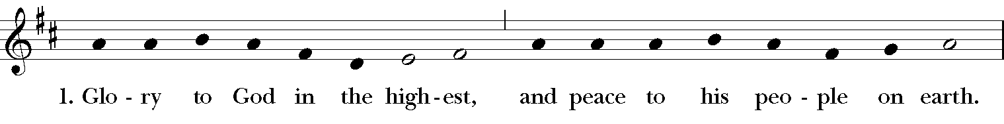

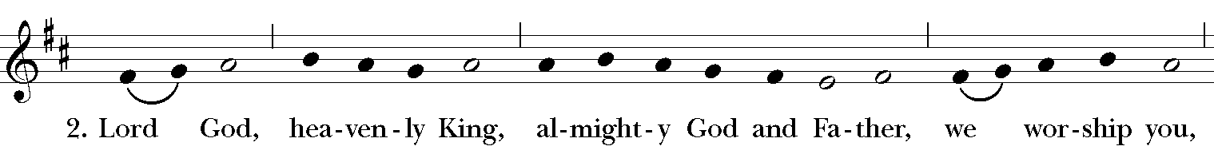

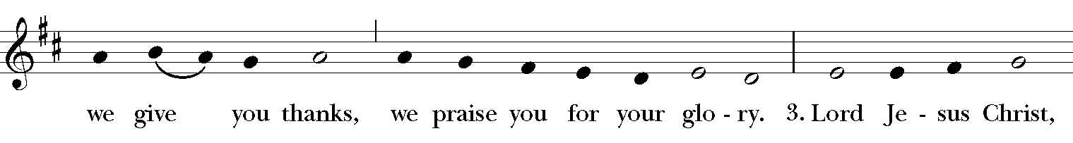

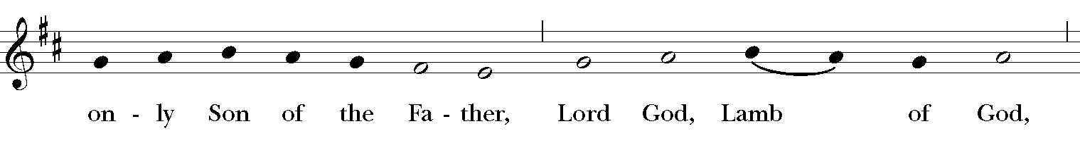

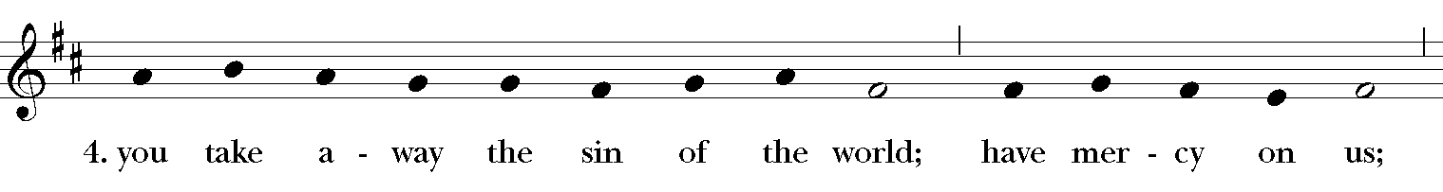

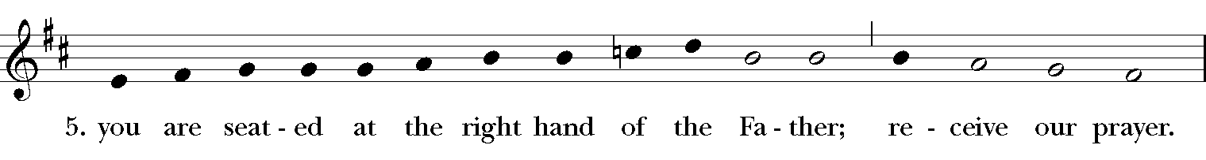

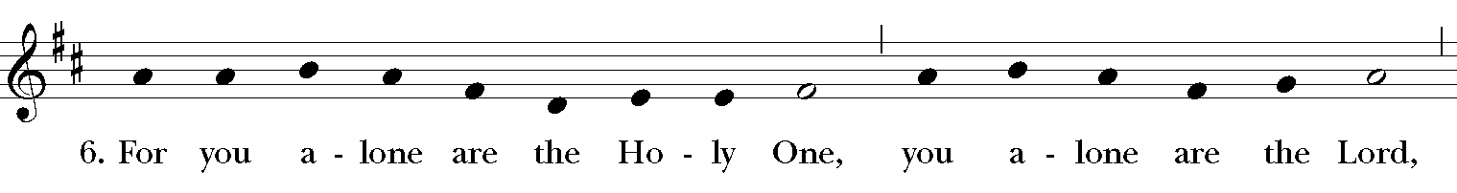

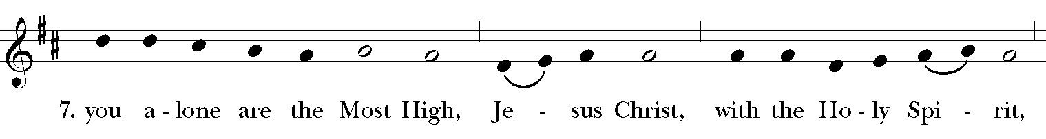

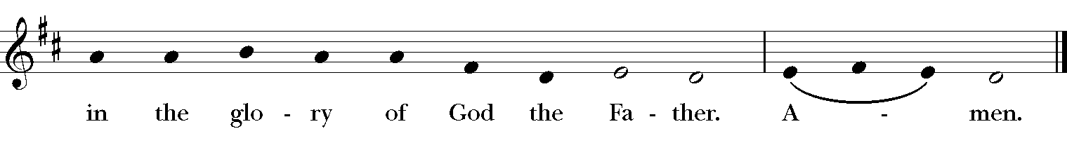

**Ministry of the Word**

*Minister* The grace of our Lord Jesus Christ, and the love of God, and the communion of the Holy Spirit, be with you all.

*People* And also with you.

*Minister* Let us pray.

*Silence.*

**The Collect of the Day**

Almighty and everlasting God, in Christ you have revealed your glory among the nations: Preserve the works of your mercy, that your Church throughout the world may persevere with steadfast faith in the confession of your Name; through Jesus Christ our Lord, who lives and reigns with you and the Holy Spirit, one God, for ever and ever.*Amen.*

**Collect for Healing**

God our healer, whose mercy is like a refining fire: by the loving- kindness of Jesus, heal us and those for whom we pray; that being renewed by you, we may witness your wholeness to our broken world; through Jesus Christ, in the power of the Spirit. *Amen.*

**Old Testament: Isaiah 53:4-12**

Surely he has borne our infirmities  
and carried our diseases;

yet we accounted him stricken,  
struck down by God, and afflicted.

But he was wounded for our transgressions,  
crushed for our iniquities;

upon him was the punishment that made us whole,  
and by his bruises we are healed.

All we like sheep have gone astray;  
we have all turned to our own way,

and the Lord has laid on him  
the iniquity of us all.

He was oppressed, and he was afflicted,  
yet he did not open his mouth;

like a lamb that is led to the slaughter,  
and like a sheep that before its shearers is silent,  
so he did not open his mouth.

By a perversion of justice he was taken away.  
Who could have imagined his future?

For he was cut off from the land of the living,  
stricken for the transgression of my people.

They made his grave with the wicked  
and his tomb with the rich,

although he had done no violence,  
and there was no deceit in his mouth.

Yet it was the will of the Lord to crush him with pain.

When you make his life an offering for sin,  
he shall see his offspring, and shall prolong his days;

through him the will of the Lord shall prosper.  
Out of his anguish he shall see light;

he shall find satisfaction through his knowledge.  
The righteous one, my servant, shall make many righteous,  
and he shall bear their iniquities.

Therefore I will allot him a portion with the great,  
and he shall divide the spoil with the strong;

because he poured out himself to death,  
and was numbered with the transgressors;

yet he bore the sin of many,  
and made intercession for the transgressors.

**The Psalm 91:9-16 *Qui habitat***

9 Because you have made the Lord your refuge, *  
and the Most High your habitation,

10 There shall no evil happen to you, *  
neither shall any plague come near your dwelling.

11 For he shall give his angels charge over you, *  
to keep you in all your ways.

12 They shall bear you in their hands, *  
lest you dash your foot against a stone.

13 You shall tread upon the lion and adder; *  
you shall trample the young lion and the serpent under your feet.

14 Because he is bound to me in love,  
therefore will I deliver him; *  
I will protect him, because he knows my Name.

15 He shall call upon me, and I will answer him; *  
I am with him in trouble;  
I will rescue him and bring him to honor.

16 With long life will I satisfy him, *  
and show him my salvation.

**The Epistle: Hebrews 5:1-10**

Every high priest chosen from among mortals is put in charge of things pertaining to God on their behalf, to offer gifts and sacrifices for sins. He is able to deal gently with the ignorant and wayward, since he himself is subject to weakness; and because of this he must offer sacrifice for his own sins as well as for those of the people. And one does not presume to take this honor, but takes it only when called by God, just as Aaron was.

So also Christ did not glorify himself in becoming a high priest, but was appointed by the one who said to him,

“You are my Son,   
today I have begotten you”;

as he says also in another place,

“You are a priest forever,   
according to the order of Melchizedek.”

In the days of his flesh, Jesus offered up prayers and supplications, with loud cries and tears, to the one who was able to save him from death, and he was heard because of his reverent submission. Although he was a Son, he learned obedience through what he suffered; and having been made perfect, he became the source of eternal salvation for all who obey him, having been designated by God a high priest according to the order of Melchizedek.

**Sequence Hymn *Haleluyan (Alleluia)* WLP 783**

*The people stand as they are able. We sing two or three verses before the proclamation of the Gospel and two or three verses after.*

**Gospel Mark 10:35-45**

James and John, the sons of Zebedee, came forward to Jesus and said to him, “Teacher, we want you to do for us whatever we ask of you.” And he said to them, “What is it you want me to do for you?” And they said to him, “Grant us to sit, one at your right hand and one at your left, in your glory.” But Jesus said to them, “You do not know what you are asking. Are you able to drink the cup that I drink, or be baptized with the baptism that I am baptized with?” They replied, “We are able.” Then Jesus said to them, “The cup that I drink you will drink; and with the baptism with which I am baptized, you will be baptized; but to sit at my right hand or at my left is not mine to grant, but it is for those for whom it has been prepared.”

When the ten heard this, they began to be angry with James and John. So Jesus called them and said to them, “You know that among the Gentiles those whom they recognize as their rulers lord it over them, and their great ones are tyrants over them. But it is not so among you; but whoever wishes to become great among you must be your servant, and whoever wishes to be first among you must be slave of all. For the Son of Man came not to be served but to serve, and to give his life a ransom for many.”

*A period of silence is kept.*

**Sermon**

**The Nicene Creed**

*The people stand as they are able.*

*All say together*

We believe in one God,

the Father, the Almighty,

maker of heaven and earth,

of all that is, seen and unseen.

We believe in one Lord, Jesus Christ,

the only Son of God,

eternally begotten of the Father,

God from God, Light from Light,

true God from true God,

begotten, not made,

of one Being with the Father.

Through him all things were made.

For us and for our salvation

he came down from heaven:

by the power of the Holy Spirit

he became incarnate from the Virgin Mary,

and was made man.

For our sake he was crucified under Pontius Pilate;

he suffered death and was buried.

On the third day he rose again

in accordance with the Scriptures;

he ascended into heaven

and is seated at the right hand of the Father.

He will come again in glory to judge the living and the dead,

and his kingdom will have no end.

We believe in the Holy Spirit, the Lord, the giver of life,

who proceeds from the Father and the Son.

With the Father and the Son he is worshiped and glorified.

He has spoken through the Prophets.

We believe in one holy catholic and apostolic Church.

We acknowledge one baptism for the forgiveness of sins.

We look for the resurrection of the dead,

and the life of the world to come. *Amen.*

**A Litany of Healing**

*The Celebrant introduces the Litany with this bidding*

Let us name before God those for whom we offer our prayers.

*The People audibly name those for whom they are interceding. A Person appointed then leads the Litany*

God the Father, your will for all people is health and salvation;

*We praise you and thank you, O Lord.*

God the Son, you came that we might have life, and might have it more abundantly;

*We praise you and thank you, O Lord.*

God the Holy Spirit, you make our bodies the temple of your presence;

*We praise you and thank you, O Lord.*

Holy Trinity, one God, in you we live and move and have our being;

*We praise you and thank you, O Lord.*

Lord, grant your healing grace to all who are sick, injured, or disabled, that they may be made whole;

*Hear us, O Lord of life.*

Grant to all who seek your guidance, and to all who are lonely, anxious, or despondent, a knowledge of your will and an awareness of your presence;

*Hear us, O Lord of life.*

Mend broken relationships, and restore those in emotional distress to soundness of mind and serenity of spirit;

*Hear us, O Lord of life.*

Bless physicians, nurses, and all others who minister to the suffering, granting them wisdom and skill, sympathy and patience;

*Hear us, O Lord of life.*

Grant to the dying peace and a holy death, and uphold by the grace and consolation of your Holy Spirit those who are bereaved;

*Hear us, O Lord of life.*

Restore to wholeness whatever is broken by human sin, in our lives, in our nation, and in the world;

*Hear us, O Lord of life.*

We pray especially for our parish members: Jamie, Nancy B., Nina A., Marian, Norma, Amanda, Duane, Ruth, Barbara, Dick, Steve, Uwe and our family and friends, Miles, Bill L, Justin W, David, John, Violet, Aaron, Hudson, Kyle, B.Y, Kathleen, George, John B., Grace, Laura and Elaine and the people of Palestine and Israel who are living in fear.

*Hear us, O Lord of life.*

We pray for those who have died in the wake of Hurricanes Helene and Milton and those who mourn remembering especially those who have died in the wars in Israel, Palestine, Ukraine and Sudan.

*Hear us, O Lord of life.*

You are the Lord who does wonders:

*You have declared your power among the peoples.*

With you, O Lord, is the well of life:

*And in your light we see light.*

Hear us, O Lord of life:

*Heal us, and make us whole.*

Let us pray.

*A period of silence follows.*

*Minister* Open us to your healing power, O God. We entrust ourselves to your care, knowing that you are doing for us and for all the world far better things than we can ask or imagine. With you as our companion and guide, strengthen us to hope for all that is good, and to fear no evil. For your love is stronger than death, and your faithfulness reaches to the heavens; and to you we give glory, Father, Son, and Holy Spirit, now and to the ages of ages. *Amen.*

*The Deacon says*

Let us confess our sins against God and our neighbor.

*Silence may be kept.*

*Minister and People*

Most merciful God,

we confess that we have sinned against you in thought, word, and deed,

by what we have done,

and by what we have left undone.

We have not loved you with our whole heart, we have not loved our neighbors as ourselves. We are truly sorry and we humbly repent.

For the sake of your Son Jesus Christ, have mercy on us and forgive us;

that we may delight in your will, and walk in your ways,

to the glory of your name. *Amen.*

*The Bishop when present, or the Priest, stands and says*

Almighty God have mercy on you, forgive you all your sins through our Lord Jesus Christ, strengthen you in all goodness, and by the power of the Holy Spirit keep you in eternal life. *Amen.*

**Laying on of Hands and Anointing**

*The minister may invite each person to be anointed to give her or his name and any particular request for prayer. The minister then lays hands upon the sick person [and anoints the person], prays silently, then prays aloud using one of the following forms or similar words.*

*N*., I lay my hands upon you [and anoint you] in the name of our Savior Jesus Christ, praying you will be strengthened and filled with God’s grace, that you may know the healing power of the Spirit. *Amen.*

*The minister may add, in these or similar words*

As you are outwardly anointed with this holy oil, so may our loving God give you the inward anointing of the Holy Spirit. May God relieve your suffering and restore you in body, mind, and spirit. May all of us in the frailty of our flesh know God’s healing power. *Amen.*

*The Laying on of Hands and Anointing concludes with the following Collect*

*Minister* May the God who goes before you through desert places by night and by day be your companion and guide; may your journey be with the saints; may the Holy Spirit be your strength, and Christ your clothing of light, in whose name we pray. *Amen.*

**The Peace**

Presider The peace of Christ be always with you.

*People*  *And also with you.*

*The Ministers and People may greet one another in the name of the Lord.*

**Announcements**

Save the Date for our Nativity Wassailing Party—December 7th (Saturday) from 2-4:30. We’ll have mulled wine, cocoa, caroling, a reading of the Christmas Story, a visit from St. Nicholas and a wonderful raffle. Join the planning group to contribute to the raffle or entertainment by calling Kim or Rev. Kirsten.

We will with thanksgiving receive offerings of **Nativity pledges and plate** today. You can contribute by sending a check to the church or by using the “Give” button on our website, [www.nativityonthehill.org](http://www.nativityonthehill.org).

All who participate in this Holy Eucharist virtually receive the full benefits of the sacrament by coming with the intention of being united with Christ and one another.

**The Holy Communion**

*A period of silence is kept.*

*The Priest says*

Offer to God a sacrifice of thanksgiving, and make good your vows to the Most High. *Psalm 50:14*

**Offertory  *How sweet the name of Jesus sounds*  H  644**

**The Great Thanksgiving**

*The Hymnal 1982, Service Music #120*









It is right, and a good and joyful thing, always and everywhere to give thanks to you, Father Almighty, Creator of heaven and earth. Through Jesus Christ our Lord; who on the first day of the week overcame death and the grave, and by his glorious resurrection opened to us the way of everlasting life. Therefore we praise you, joining our voices with Angels and Archangels and with all the company of heaven, who for ever sing this hymn to proclaim the glory of your Name:

*The Hymnal 1982, Service Music #124*

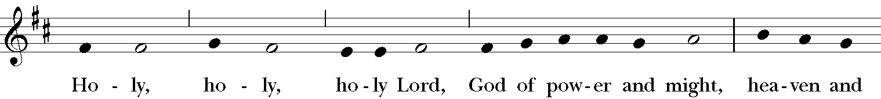

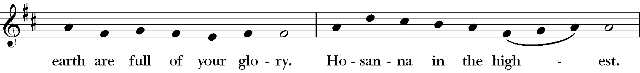

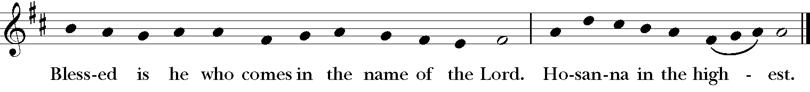

*Then the Presider continues*

Holy and gracious Father: In your infinite love you made us for yourself; and, when we had fallen into sin and become subject to evil and death, you, in your mercy, sent Jesus Christ, your only and eternal Son, to share our human nature, to live and die as one of us, to reconcile us to you, the God and Father of all.

He stretched out his arms upon the cross, and offered himself in obedience to your will, a perfect sacrifice for the whole world.

On the night he was handed over to suffering and death, our Lord Jesus Christ took bread; and when he had given thanks to you, he broke it, and gave it to his disciples, and said,

"Take, eat: This is my Body, which is given for you. Do this for the remembrance of me."

After supper he took the cup of wine; and when he had given thanks, he gave it to them, and said,

"Drink this, all of you: This is my Blood of the new Covenant, which is shed for you and for many for the forgiveness of sins. Whenever you drink it, do this for the remembrance of me."

Therefore we proclaim the mystery of faith:

*Presider and People*

Christ has died.

Christ is risen.

Christ will come again.

We celebrate the memorial of our redemption, O Father, in this sacrifice of praise and thanksgiving. Recalling his death, resurrection, and ascension, we offer you these gifts.

Sanctify them by your Holy Spirit to be for your people the Body and Blood of your Son, the holy food and drink of new and unending life in him. Sanctify us also that we may faithfully receive this holy Sacrament, and serve you in unity, constancy, and peace; and at the last day bring us with all your saints into the joy of your eternal kingdom.

All this we ask through your Son Jesus Christ. By him, and with him, and in him, in the unity of the Holy Spirit all honor and glory is yours, Almighty Father, now and forever. 

**Lord's Prayer**

*Presider*

As our Savior Christ has taught us, we now pray,

*People and Presider*

Our Father, who art in heaven,

hallowed be thy Name,

thy kingdom come,

thy will be done,

on earth as it is in heaven.

Give us this day our daily bread.

And forgive us our trespasses,

as we forgive those who trespass against us.

And lead us not into temptation,

but deliver us from evil.

For thine is the kingdom, and the power, and the glory,

for ever and ever. Amen.

**The Breaking of the Bread**  
*A period of silence is kept.*

**Fraction Anthem** *The Hymnal 1982, Service Music #161*

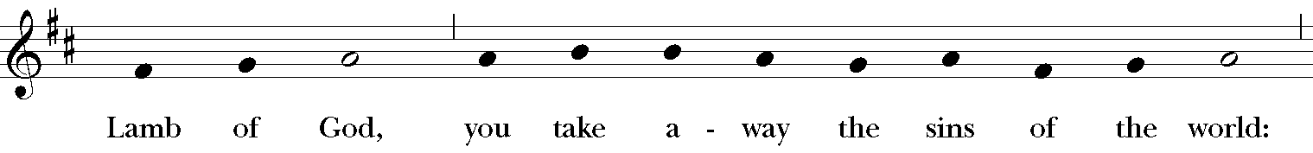

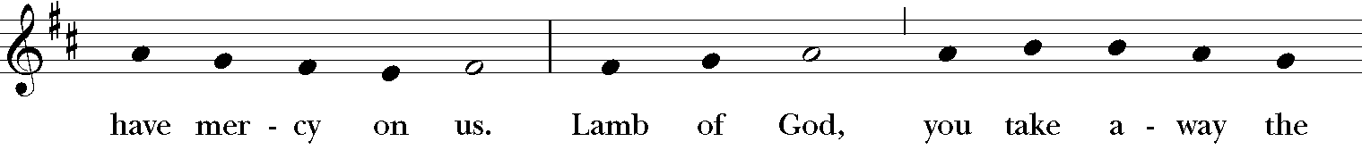

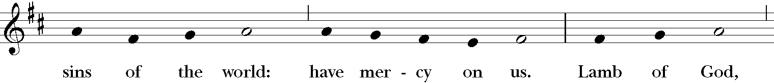

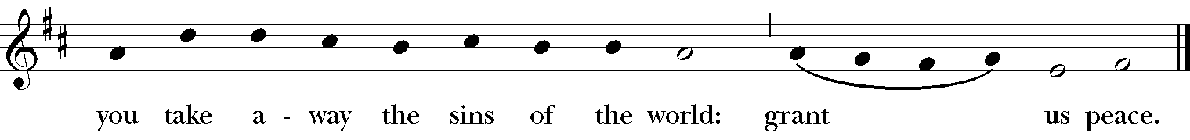

*The Priest invites the people to Communion*

The Gifts of God for the People of God. Take them in remembrance that Christ died for you, and feed on him in your hearts by faith, with thanksgiving.

*All who are drawn to Christ are invited to take communion at the rail. If you cannot approach the rail, please alert an usher and communion will be brought to you. If you would like a blessing instead of the elements, please indicate by crossing your hands at your chest.*

**Communion Hymn *O Christ, the healer* W.L.P  772**

**Post-communion Prayer**

*Presider and People*

Eternal God, heavenly Father, you have graciously accepted us as living members of your Son our Savior Jesus Christ, and you have fed us with spiritual food in the Sacrament of his Body and Blood. Send us now into the world in peace, and grant us strength and courage to love and serve you with gladness and singleness of heart; through Christ our Lord. Amen.

**Blessing**

*The Bishop or Priest says*

Holy eternal Majesty, Holy incarnate Word, Holy abiding Spirit, Bless you for evermore. *Amen.*

*Parish announcements are made at this time. Blessings for birthdays and anniversaries are offered.*

**Birthday and Anniversary Blessing prayer**

O God, our times are in your hands: Look with favor, we pray, on your servants as they begin another year. Grant that they may grow in wisdom and grace, and strengthentheir trust in your goodness all the days of theirlives; through Jesus Christ our Lord. *Amen.*

**Recessional Hymn *Jesu, Jesu, fill us with your love* H 602**

**Dismissal**

|  |  |
| --- | --- |
| **Deacon** | Let us go forth in the name of Christ. |
| ***People*** | *Thanks be to God.* |

**Postlude*Let it Be* by Lennon and McCartney**