Nativity Worships
Season of the Epiphany 2025

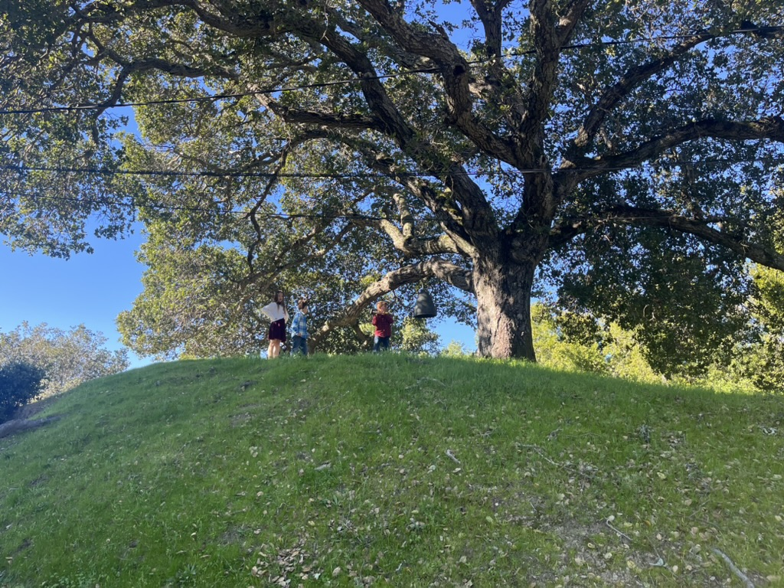
Facebook Livestream

Youtube Channel

Episcopal Church of the Nativity
San Rafael, California
The church on the hill in Lucas Valley
333 Ellen Dr.
San Rafael, CA 94903
415-479-7023
www.nativityonthehill.org

The Rev. Kirsten Snow Spalding, Rector
The Rev. Scott Sinclair, Priest in Residence
The Rev. Rebecca Morehouse, Deacon

Prelude

The Word of God

Entrance Rite

Entrance Hymn
All of the hymns are printed on the bulletin insert and posted on the hymn board.

Opening Acclamation
The people standing, the Presider says
Grace and peace to you from God our Father
and the Lord Jesus Christ.
Amen.

Collect for Purity
The Presider may say
Almighty God, to you all hearts are open, all desires known, and from you no secrets are hid: Cleanse the thoughts of our hearts by the inspiration of your Holy Spirit, that we may perfectly love you, and worthily magnify your holy Name; through Christ our Lord. Amen.

Opening Anthem or Song of Praise S 96 (Schubert/Proulx)
The following is sung, all standing
The Collect of the Day
Presider | God be with you.
People | And also with you.
Presider | Let us pray.
The people stand while the Presider reads the collect of the day.

The Lessons

First Reading
The people sit.
Silence may follow.

Psalm
Remain seated.

Second Reading
The people sit.
Silence may follow.

Sequence Hymn
All stand. We sing the first one or two verses before the Gospel and one or two verses after.

Gospel
All stand.

The Sermon

The Creed
All stand.
We believe in one God,
the Father, the Almighty,
maker of heaven and earth,
of all that is, seen and unseen.
We believe in one Lord, Jesus Christ,
the only Son of God,
eternally begotten of the Father,
God from God, Light from Light,
true God from true God,
begotten, not made,
of one Being with the Father.
Through him all things were made.
For us and for our salvation
he came down from heaven:
by the power of the Holy Spirit
he became incarnate from the Virgin Mary,
and was made man.
For our sake he was crucified under Pontius Pilate;
he suffered death and was buried.
On the third day he rose again
in accordance with the Scriptures;
he ascended into heaven
and is seated at the right hand of the Father.
He will come again in glory to judge the living and the dead,
and his kingdom will have no end.
We believe in the Holy Spirit, the Lord, the giver of life,
who proceeds from the Father and the Son.
With the Father and the Son he is worshiped and glorified.
He has spoken through the Prophets.
We believe in one holy catholic and apostolic Church.
We acknowledge one baptism for the forgiveness of sins.
We look for the resurrection of the dead,
and the life of the world to come. Amen.

The Prayers of the People

Through Jesus, whom we confess as Lord,
we give thanks and praise to the Father,
calling on the one who is judge of all:
Father, your kingdom come.
Father, your kingdom come.

For all who have seen the radiance of your glory revealed to all the nations in your Son,
we pray to you, O Lord:
Father, your kingdom come.

For all the peoples of the world;
that they may know you as the God of peace,
we pray to you, O Lord:
Father, your kingdom come.

For nations, for leaders and governments;
that integrity may mark all their dealings,
we pray to you O Lord:
Father, your kingdom come.

For all who labour for righteousness;
that your presence and help may give them courage,
we pray to you, O Lord:
Father, your kingdom come.

For communities torn by dissension and strife;
that your forgiveness may bring them healing,
we pray to you, O Lord:
Father, your kingdom come.

For the anxious, the lonely, the bereaved; remembering especially our parish members: ______ and our family and friends _________
that consolation and peace may be theirs,
we pray to you, O Lord:
Father, your kingdom come.

For the Church, your household and family;
that we may be firm in the confession of our hope,
we pray to you, O Lord:
Father, your kingdom come.

For Sean our Bishop, Austin our Diocesan Bishop, for those on our Diocesan cycle of prayer__________ and for all who bear Christ's name;
that their lives may proclaim your glory,
we pray to you, O Lord:
Father, your kingdom come.

For those who are separated from us by death;
remembering especially ________ that theirs may be the kingdom which is unshakeable,
we pray to you, O Lord:
Father, your kingdom come.

The Presider adds a concluding Collect.
O God of peace,
who brought again from the dead our Lord Jesus,
that great Shepherd of the sheep:
make us perfect in all goodness to do your will
and to be what you would have us be;
through him to whom be glory for ever,
Jesus Christ our Lord.
Amen.

Confession of Sin
The Deacon or Presider says
God is love and we are God’s children,
There is no room for fear in love.
We love because God loved us first.

Let us confess our sins in penitence and faith.

Silence
Minister and People

God our Father, we confess to you
and to our fellow members in the Body of Christ
that we have sinned in thought, word and deed,
and in what we have failed to do.
We are truly sorry.
Forgive us our sins,
and deliver us from the power of evil.
For the sake of your Son who died for us,
Jesus Christ, our Lord.

The Priest stands and says
God, who is both power and love,
forgive you and free you from your sins,
heal and strengthen you by the Holy Spirit
and raise you to new life in Christ our Lord.
Amen.

The Peace
All stand.
Presider | The peace of Christ be always with you.
People | And also with you.

Then the Ministers and the People may greet one another in the name of the Lord.

Announcements
Announcements are printed on the insert to the bulletin and made orally at this point in the service. If you would like to include an announcement for the community, please send a note to the office before Friday when the bulletin insert goes to print.

The Holy Communion

Offertory Sentence
The Presider says
Offer to God a sacrifice of thanksgiving, and make good your vows to the Most High. Psalm 50:14

Offertory Hymn (BCP p. 361)

The Great Thanksgiving

Presentation of Gifts
The Presider says
Let us present our offerings to the Lord.

Yours, Lord, is the greatness, the power, the glory,
the splendour, and the majesty; for everything in
heaven and on earth is yours.
All things come from you,
People and of your own we give you.

Sursum Corda
The People remain standing.
Presider | The Lord be with you.
People | And also with you.
Presider | Lift up your hearts.
People | We lift them to the Lord.
Presider | Let us give thanks to the Lord our God.
People | It is right to give him thanks and praise.

Opening Prayer
Worship and praise belong to you, God our maker.
Out of nothing, you called all worlds into being,
and still you draw the universe to its fulfilment.
Day and night celebrate your glory
till time shall be no more.
In Christ, your only begotten Son,
you have revealed yourself to the world.
By the leading of a star,
you made him known to the nations
as the son of David and king of Israel;
that in following him, we might be led
from darkness into his marvellous light.

Filled with the Spirit,
who descended upon your Son
at his Baptism in the Jordan,
we who are baptised in his name
strive for his heavenly kingdom
in whose radiance we are transfigured
and the earth transformed.

As children of your redeeming purpose
we offer you our praise,
with angels and archangels
and the whole company of heaven
singing the hymn of your unending glory:

Sanctus S 130 Holy, holy, holy (Schubert/Proulx)
Presider and People

Words of Institution
Glory and thanksgiving be to you,
most loving Father.
In Jesus the Messiah you have come to us.
Our hope is built on him in whom you are well pleased.
Having been shown to the world as your beloved Son,
he proclaimed the good news of your kingdom.
The blind received their sight, the lame walked,
the lepers were cleansed, and the captives set free.
At his word, water became wine,
the hungry were filled with bread,
and the dead were raised.

Before he was given up to suffering and death,
desiring to complete the work
for which he came into the world,
at supper with his disciples he took bread
and offered you thanks.
He broke the bread, and gave it to them, saying:
“Take, eat. This is my Body: it is broken for you.”

After supper, he took the cup, he offered you thanks,
and gave it to them saying: “Drink this, all of you.
This is my Blood of the new covenant;
it is poured out for you, and for all, that sins may be forgiven.
Do this in remembrance of me.”

We now obey your Son's command.
We recall his blessed passion and death,
his glorious resurrection and ascension;
and we look for the coming of his Kingdom.
Made one with him, we offer you these gifts
and with them ourselves,
a single, holy, living sacrifice.

Epiclesis
Hear us, most merciful Father,
and send your Holy Spirit upon us
and upon this bread and this wine,
that, overshadowed by your Spirit’s life-giving power,
they may be the Body and Blood of your Son,
and we may be kindled with the fire of your love
and renewed for the service of your Kingdom.
Help us, who are baptised into the
fellowship of Christ's Body
to live and work to your praise and glory;
may we grow together in unity and love
until at last, in your new creation,
we enter into our heritage
in the company of the Virgin Mary,
the apostles, and prophets,
and of all our brothers and sisters living and departed.'

Through Jesus Christ our Lord,
with whom, and in whom,
in the unity of the Holy Spirit,
all honour and glory be to you,
Lord of all ages, world without end.
Amen.

The Lord’s Prayer
As our Savior Christ has taught us, we now pray,
People and Presider
Our Father in heaven,
hallowed be your Name,
your kingdom come,
your will be done, on earth as in heaven.
Give us today our daily bread.
Forgive us our sins
as we forgive those who sin against us.
Save us from the time of trial
and deliver us from evil.
For the kingdom, the power,
and the glory are yours,
now and forever. Amen.

The Breaking of the Bread

Fraction Anthem S 164 Jesus, Lamb of God (Schubert/Proulx)

Invitation
The Presider says
The Gifts of God for the People of God.

Distribution
The ministers receive the Sacrament in both kinds, and then immediately deliver it to the people.
The Bread and the Cup are given to the communicants with these words
The Body of Christ, the bread of heaven. [Amen.]
The Blood of Christ, the cup of salvation. [Amen.]

Communion Hymn

Post-Communion Prayer
Loving God, your steadfast purpose is the completion of all things in your Son. May we who have received the pledges of the kingdom, live by faith, walk in hope and be renewed in love, until the world reflects your glory and you are all in all; through Jesus Christ our Lord. Amen.

Blessing
Christ the Son of God gladden your hearts
with the good news of God’s kingdom;
and the blessing
of God almighty, the Father,
the Son and the Holy Spirit,
be among you and remain with you always. Amen.

Post-Communion Hymn

Dismissal

Go in peace to love and serve the Lord.
In the name of Christ. Amen.

Postlude

From riteplanning.com.
Copyright © 2025 Church Publishing Inc. All rights reserved.

