Nativity Worships
Lent 2025

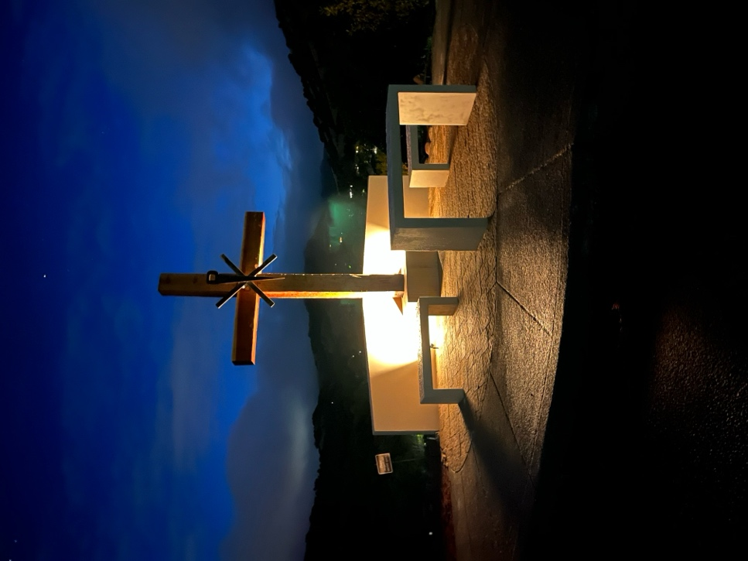

The Very Rev. Kirsten Snow Spalding, Rector
The Rev. Scott Gambrill Sinclair, Priest in Residence
The Rev. Rebecca Morehouse, Deacon

333 Ellen Drive
San Rafael, CA 93903
www.nativityonthehill.org
415-479-7023

The Word of God

Penitential Order

Entrance Hymn
Hymn numbers are printed in the bulletin insert and posted on the hymn board. It is customary to stand for the hymns if you are able.

Opening Acclamation
The people standing, the Presider says

Decalogue
The Decalogue is said, the People kneeling.
Hear the commandments of God to his people:
I am the Lord your God who brought you out of bondage.
You shall have no other gods but me.
Amen. Lord have mercy.
You shall not make for yourself any idol.
Amen. Lord have mercy.
You shall not invoke with malice the Name of the Lord your God.
Amen. Lord have mercy.
Remember the Sabbath Day and keep it holy.
Amen. Lord have mercy.
Honor your father and your mother.
Amen. Lord have mercy.
You shall not commit murder.
Amen. Lord have mercy.
You shall not commit adultery.
Amen. Lord have mercy.
You shall not steal.
Amen. Lord have mercy.
You shall not be a false witness.
Amen. Lord have mercy.
You shall not covet anything that belongs to your neighbor.
Amen. Lord have mercy.
Confession of Sin
The Deacon or Presider says
Let us confess our sins against God and our neighbor.
Silence may be kept.
Minister and People
Most merciful God,
we confess that we have sinned against you
in thought, word, and deed,
by what we have done,
and by what we have left undone.
We have not loved you with our whole heart;
we have not loved our neighbors as ourselves.
We are truly sorry and we humbly repent.
For the sake of your Son Jesus Christ,
have mercy on us and forgive us;
that we may delight in your will,
and walk in your ways,
to the glory of your Name. Amen.
The Priest stands and says
Almighty God have mercy on you, forgive you all your sins through our Lord Jesus Christ, strengthen you in all goodness, and by the power of the Holy Spirit keep you in eternal life. Amen.

Opening Anthem or Song of Praise S 100 Holy God (Hurd)
The following is sung, all standing

The Collect of the Day

Presider | The Lord be with you.
People | And also with you.
Presider | Let us pray.

The collect of the day and all readings are printed on the insert to the bulletin.
The Lessons

First Reading
The people sit.
Silence may follow.

Psalm
Remain seated.

Second Reading
The people sit.
Silence may follow.

Sequence Hymn
Hymn numbers are printed in the bulletin insert and posted on the hymn board. It is customary to stand for the hymns if you are able. We sing one or two verses before the Gospel and one verse after.

Gospel
All stand.

The Sermon

The Creed
All stand.
We believe in one God,
the Father, the Almighty,
maker of heaven and earth,
of all that is, seen and unseen.
We believe in one Lord, Jesus Christ,
the only Son of God,
eternally begotten of the Father,
God from God, Light from Light,
true God from true God,
begotten, not made,
of one Being with the Father.
Through him all things were made.
For us and for our salvation
he came down from heaven:
by the power of the Holy Spirit
he became incarnate from the Virgin Mary,
and was made man.
For our sake he was crucified under Pontius Pilate;
he suffered death and was buried.
On the third day he rose again
in accordance with the Scriptures;
he ascended into heaven
and is seated at the right hand of the Father.
He will come again in glory to judge the living and the dead,
and his kingdom will have no end.
We believe in the Holy Spirit, the Lord, the giver of life,
who proceeds from the Father and the Son.
With the Father and the Son he is worshiped and glorified.
He has spoken through the Prophets.
We believe in one holy catholic and apostolic Church.
We acknowledge one baptism for the forgiveness of sins.
We look for the resurrection of the dead,
and the life of the world to come. Amen.

The Prayers of the People
All remain standing.
Let us pray for the Church and for the world.
In our Diocesan cycle of prayer, we pray for: __________________.Grant, Almighty God, that all who confess your Name may be united in your truth, live together in your love, and reveal your glory in the world.
Silence
Lord, in your mercy
Hear our prayer.
Guide the people of this land, and of all the nations, in the ways of justice and peace; that we may honor one another and serve the common good.
Silence
Lord, in your mercy
Hear our prayer.
Give us all a reverence for the earth as your own creation, that we may use its resources rightly in the service of others and to your honor and glory.
Silence
Lord, in your mercy
Hear our prayer.
Bless all whose lives are closely linked with ours, and grant that we may serve Christ in them, and love one another as he loves us.
Silence
Lord, in your mercy
Hear our prayer.
We pray for our parish members and our friends and family:_______________Comfort and heal all those who suffer in body, mind, or spirit; give them courage and hope in their troubles, and bring them the joy of your salvation.
Silence
Lord, in your mercy
Hear our prayer.
We remember today those who have died: _____________________. We commend to your mercy all who have died, that your will for them may be fulfilled; and we pray that we may share with all your saints in your eternal kingdom.
Silence
Lord, in your mercy
Hear our prayer.
The Presider adds a concluding Collect.

The Peace
All stand.
Presider | The peace of the Lord be always with you.
People | And also with you.

Then the Ministers and the People may greet one another in the name of the Lord.

Announcements

The Holy Communion

Offertory Sentence
The Presider says
If you are offering your gift at the altar, and there remember that your brother has something against you, leave your gift there before the altar and go; first be reconciled to your brother, and then come and offer your gift. Matthew 5:23, 24

Offertory Hymn
Hymn numbers are printed in the bulletin insert and posted on the hymn board. It is customary to stand for the hymns if you are able.

The Great Thanksgiving

Sursum Corda S 120 Lift up your hearts
The People remain standing.
Proper Preface
Facing the Holy Table, the Presider proceeds
It is right, and a good and joyful thing, always and everywhere to give thanks to you, Almighty God, Creator of heaven and earth.
Through Jesus Christ our Lord, who was tempted in every way as we are, yet did not sin. By his grace we are able to triumph over every evil, and to live no longer for ourselves alone, but for him who died for us and rose again.
Therefore we praise you, joining our voices with Angels and Archangels and with all the company of heaven, who for ever sing this hymn to proclaim the glory of your Name:

Sanctus S 124 Holy, holy, holy (Hurd)
Presider and People

Words of Institution
The People stand or kneel.
The Presider continues
Holy and gracious Father: In your infinite love you made us for yourself; and, when we had fallen into sin and become subject to evil and death, you, in your mercy, sent Jesus Christ, your only and eternal Son, to share our human nature, to live and die as one of us, to reconcile us to you, the God and Father of all.
He stretched out his arms upon the cross, and offered himself in obedience to your will, a perfect sacrifice for the whole world.
On the night he was handed over to suffering and death, our Lord Jesus Christ took bread; and when he had given thanks to you, he broke it, and gave it to his disciples, and said, “Take, eat: This is my Body, which is given for you. Do this for the remembrance of me.”
After supper he took the cup of wine; and when he had given thanks, he gave it to them, and said, “Drink this, all of you: This is my Blood of the new Covenant, which is shed for you and for many for the forgiveness of sins. Whenever you drink it, do this for the remembrance of me.”
Therefore we proclaim the mystery of faith:
Presider and People
Christ has died.
Christ is risen.
Christ will come again.

Epiclesis
The Presider continues
We celebrate the memorial of our redemption, Almighty God, in this sacrifice of praise and thanksgiving. Recalling his death, resurrection, and ascension, we offer you these gifts.
Sanctify them by your Holy Spirit to be for your people the Body and Blood of your Son, the holy food and drink of new and unending life in him. Sanctify us also that we may faithfully receive this holy Sacrament, and serve you in unity, constancy, and peace; and at the last day bring us with all your saints into the joy of your eternal kingdom.
All this we ask through your Son Jesus Christ. By him, and with him, and in him, in the unity of the Holy Spirit all honor and glory is yours, Almighty God, now and for ever.
The Lord’s Prayer
As our Savior Christ has taught us, we now pray,
People and Presider
Our Father in heaven,
hallowed be your Name,
your kingdom come,
your will be done, on earth as in heaven.
Give us today our daily bread.
Forgive us our sins
as we forgive those who sin against us.
Save us from the time of trial
and deliver us from evil.
For the kingdom, the power,
and the glory are yours,
now and forever. Amen.

The Breaking of the Bread

Fraction Anthem S 153 Christ our Passover (Chant/Martens)

Invitation
The Presider says
The Gifts of God for the People of God.

Distribution
The ministers receive the Sacrament in both kinds, and then immediately deliver it to the people.
The Bread and the Cup are given to the communicants with these words
The Body of Christ, the bread of heaven. [Amen.]
The Blood of Christ, the cup of salvation. [Amen.]
If you wish to receive a blessing instead of the bread and wine, cross your hands at your chest when you come to the rail and the priest will offer you a blessing.

Post-Communion Prayer
After Communion, the Presider says
Let us pray.
Presider and People
Eternal God, heavenly Father,
you have graciously accepted us as living members
of your Son our Savior Jesus Christ,
and you have fed us with spiritual food
in the Sacrament of his Body and Blood.
Send us now into the world in peace,
and grant us strength and courage
to love and serve you
with gladness and singleness of heart;
through Christ our Lord. Amen.

Blessing
The Priest blesses the people, saying
The blessing, mercy, and grace of God Almighty, the Father, the Son, and the Holy Spirit, be upon you, and remain with you for ever. Amen.

Post-Communion Hymn
Hymn numbers are printed in the bulletin insert and posted on the hymn board. It is customary to stand for the hymns if you are able.

Dismissal
 | Go in peace to love and serve Jesus Christ our Savior.
People | Thanks be to God.

From riteplanning.com.
Copyright © 2025 Church Publishing Inc. All rights reserved.

