Christmas Morning

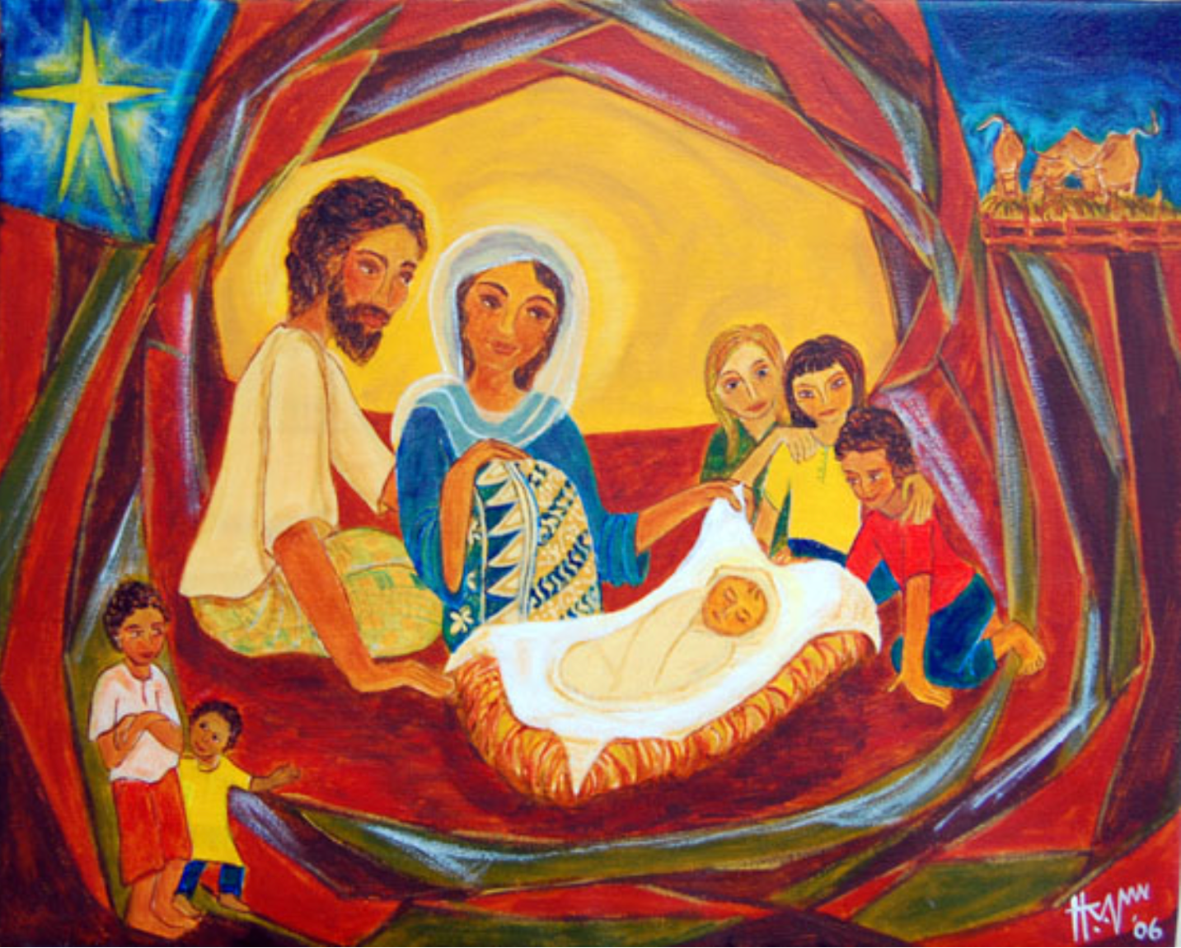

December 25, 2024, 10 a.m.

Episcopal Church of the Nativity
San Rafael, California

Merry Christmas and Peace to you!

The Rev. Kirsten Snow Spalding, Rector
The Rev. Scott Sinclair, Priest in Residence
The Rev. Lynn Oldham Robinett, Assisting Priest
The Rev. Rebecca Morehouse, Deacon
Prelude In the Bleak Midwinter by Christina Rossetti and Gustav Holst
Ray Hickman, guest pianist

The Word of God

Entrance Rite

Entrance Hymn Angels we have heard on high H96
All stand to sing together.

Opening Acclamation
The people standing, the Presider says
 | Blessed be God: Father, Son, and Holy Spirit.
People | And blessed be his kingdom, now and for ever. Amen.

Collect for Purity
The Presider may say
Almighty God, to you all hearts are open, all desires known, and from you no secrets are hid: Cleanse the thoughts of our hearts by the inspiration of your Holy Spirit, that we may perfectly love you, and worthily magnify your holy Name; through Christ our Lord. Amen.

Song of Praise The first Nowell the angel did say H 109
All stand to sing together.

The Collect of the Day
Presider | The Lord be with you.
People | And also with you.
Presider | Let us pray.

Almighty God, you have given your only-begotten Son to take our nature upon him, and to be born [this day] of a pure virgin: Grant that we, who have been born again and made your children by adoption and grace, may daily be renewed by your Holy Spirit; through our Lord Jesus Christ, to whom with you and the same Spirit be honor and glory, now and for ever. Amen.

The Lessons

First Reading: Isaiah 62:6-12
The people sit.
A Reading from the book of the prophet Isaiah.
⁶Upon your walls, O Jerusalem,
I have posted sentinels;
all day and all night
they shall never be silent.
You who remind the Lord,
take no rest,
⁷and give him no rest
until he establishes Jerusalem
and makes it renowned throughout the earth.
⁸The Lord has sworn by his right hand
and by his mighty arm:
I will not again give your grain
to be food for your enemies,
and foreigners shall not drink the wine
for which you have labored;
⁹but those who garner it shall eat it
and praise the Lord,
and those who gather it shall drink it
in my holy courts.
¹⁰Go through, go through the gates,
prepare the way for the people;
build up, build up the highway,
clear it of stones,
lift up an ensign over the peoples.
¹¹The Lord has proclaimed
to the end of the earth:
Say to daughter Zion,
“See, your salvation comes;
his reward is with him,
and his recompense before him.”
¹²They shall be called, “The Holy People,
The Redeemed of the Lord“;
and you shall be called, “Sought Out,
A City Not Forsaken.”

Reader | The Word of the Lord.
People | Thanks be to God.
Silence may follow.
Psalm: Psalm 97
Remain seated.
¹The Lord is King;
let the earth rejoice; *
let the multitude of the isles be glad.
²Clouds and darkness are round about him, *
righteousness and justice are the foundations of his throne.
³A fire goes before him *
and burns up his enemies on every side.
⁴His lightnings light up the world; *
the earth sees it and is afraid.
⁵The mountains melt like wax at the presence of the Lord, *
at the presence of the Lord of the whole earth.
⁶The heavens declare his righteousness, *
and all the peoples see his glory.
⁷Confounded be all who worship carved images
and delight in false gods! *
Bow down before him, all you gods.
⁸Zion hears and is glad, and the cities of Judah rejoice, *
because of your judgments, O Lord.
⁹For you are the Lord,
most high over all the earth; *
you are exalted far above all gods.
¹⁰The Lord loves those who hate evil; *
he preserves the lives of his saints
and delivers them from the hand of the wicked.
¹¹Light has sprung up for the righteous, *
and joyful gladness for those who are truehearted.
¹²Rejoice in the Lord, you righteous, *
and give thanks to his holy Name.

Second Reading: Titus 3:4-7
The people sit.
A Reading from Paul's letter to Titus.
⁴When the goodness and loving kindness of God our Savior appeared, ⁵he saved us, not because of any works of righteousness that we had done, but according to his mercy, through the water of rebirth and renewal by the Holy Spirit. ⁶This Spirit he poured out on us richly through Jesus Christ our Savior, ⁷so that, having been justified by his grace, we might become heirs according to the hope of eternal life.

Reader | The Word of the Lord.
People | Thanks be to God.
Silence may follow.

Sequence Hymn It came upon the midnight clear H 89

Gospel: Luke 2: 8-20
All stand.
Deacon | The Holy Gospel of our Lord Jesus Christ according to Luke.
People | Glory to you, Lord Christ.

⁸In that region there were shepherds living in the fields, keeping watch over their flock by night. ⁹Then an angel of the Lord stood before them, and the glory of the Lord shone around them, and they were terrified. ¹⁰But the angel said to them, “Do not be afraid; for see—I am bringing you good news of great joy for all the people: ¹¹to you is born this day in the city of David a Savior, who is the Messiah, the Lord. ¹²This will be a sign for you: you will find a child wrapped in bands of cloth and lying in a manger.” ¹³And suddenly there was with the angel a multitude of the heavenly host, praising God and saying,
¹⁴“Glory to God in the highest heaven,
and on earth peace among those whom he favors!”
¹⁵When the angels had left them and gone into heaven, the shepherds said to one another, “Let us go now to Bethlehem and see this thing that has taken place, which the Lord has made known to us.” ¹⁶So they went with haste and found Mary and Joseph, and the child lying in the manger. ¹⁷When they saw this, they made known what had been told them about this child; ¹⁸and all who heard it were amazed at what the shepherds told them. ¹⁹But Mary treasured all these words and pondered them in her heart. ²⁰The shepherds returned, glorifying and praising God for all they had heard and seen, as it had been told them.

Deacon | The Gospel of the Lord.
People | Praise to you, Lord Christ.

HOMILY The Rev. Kirsten Snow Spalding

Hymn What child is this, who, laid to rest (Greensleeves) H 115

The Creed
All stand.
We believe in one God,
the Father, the Almighty,
maker of heaven and earth,
of all that is, seen and unseen.
We believe in one Lord, Jesus Christ,
the only Son of God,
eternally begotten of the Father,
God from God, Light from Light,
true God from true God,
begotten, not made,
of one Being with the Father.
Through him all things were made.
For us and for our salvation
he came down from heaven:
by the power of the Holy Spirit
he became incarnate from the Virgin Mary,
and was made man.
For our sake he was crucified under Pontius Pilate;
he suffered death and was buried.
On the third day he rose again
in accordance with the Scriptures;
he ascended into heaven
and is seated at the right hand of the Father.
He will come again in glory to judge the living and the dead,
and his kingdom will have no end.
We believe in the Holy Spirit, the Lord, the giver of life,
who proceeds from the Father and the Son.
With the Father and the Son he is worshiped and glorified.
He has spoken through the Prophets.
We believe in one holy catholic and apostolic Church.
We acknowledge one baptism for the forgiveness of sins.
We look for the resurrection of the dead,
and the life of the world to come. Amen.

The Prayers of the People
All remain standing.
With all our heart and with all our mind, let us pray to the Lord, saying, “Lord, have mercy.”

For the peace of the world, for the welfare of the holy Church of God, and for the unity of all peoples, let us pray to the Lord.
Lord, have mercy.

For our Bishop Sean, our Diocesan Bishop Austin, our Nativity clergy, Kirsten, Scott and Rebecca and for all the clergy and people, let us pray to the Lord.
Lord, have mercy.

For our President Joe, for the leaders of the nations, and for all in authority, let us pray to the Lord.
Lord, have mercy.

For this city of San Rafael, for every city and community, and for those who live in them, let us pray to the Lord.
Lord, have mercy.

For the good earth which God has given us, and for the wisdom and will to conserve it, let us pray to the Lord.
Lord, have mercy.

For those who travel on land, on water, or in the air, let us pray to the Lord.
Lord, have mercy.

For the aged and infirm, for the widowed and orphans, and for the sick and the suffering, let us pray to the Lord.
Lord, have mercy.

For our parish members Jamie, Nancy B, Nina A, Marian, Norma, Duane, Amanda, Ruth, Steve K, Dick, Barbara B, and Uwe; and our family and friends, Miles, David, John, Violet & John, B. Y., Justin, John B, Laura, Tanner, Lisa, Phil, Greg, Nick and Phoebe, let us pray to the Lord.
Lord, have mercy.

For the poor and the oppressed, for the unemployed and the destitute, for prisoners and captives, and for all who remember and care for them, let us pray to the Lord.
Lord, have mercy.

For all who have died in the hope of the resurrection, remembering especially Bill Shepherd and for all the departed, let us pray to the Lord.
Lord, have mercy.

For deliverance from all danger, violence, oppression, and degradation, remember especially the people of Ukraine, Palestine, and Sudan, let us pray to the Lord.
Lord, have mercy.

For the absolution and remission of our sins and offenses, let us pray to the Lord.
Lord, have mercy.

That we may end our lives in faith and hope, without suffering and without reproach, let us pray to the Lord.
Lord, have mercy.

In the communion of Mary and Joseph and of all the saints, let us commend ourselves, and one another, and all our life, to Christ our God.
To thee, O Lord our God.
Silence
The Presider adds a concluding Collect.

The Peace
All stand.
Presider | The peace of the Lord be always with you.
People | And also with you.

Then the Ministers and the People may greet one another in the name of the Lord.
ANNOUNCEMENTS
Join us for a Christmas Brunch hosted by Revs. Kirsten, Scott and Rebecca, family and friends are welcome.

December 29th, there will be no 8 a.m. service. In place of our Holy Eucharist service, we will have Christmas Lessons and Carols 10 a.m. in the sanctuary and livestreamed on Facebook.

Join us for Epiphany Prayers at 5:30 on January 6th. A time of candlelit contemplation followed by Evening Prayer with the story of the coming of the Magi (Mt. 2:1-12). Co-hosted by Nativity and St. Paul’s.

Volunteer opportunity. Nativity will lead the cooking of a special meal for our neighbors who live outside. January 7th 4:30-7 p.m. at First Presbyterian Church San Rafael. Email Rev. Kirsten for details at nativityonthehill@gmail.com.

The Holy Communion

Offertory Sentence
The Presider says
Offer to God a sacrifice of thanksgiving, and make good your vows to the Most High. Psalm 50:14

Offertory Hymn God rest you merry gentlemen H105

The Great Thanksgiving

Sursum Corda
The People remain standing.
Presider | The Lord be with you.
People | And also with you.
Presider | Lift up your hearts.
People | We lift them to the Lord.
Presider | Let us give thanks to the Lord our God.
People | It is right to give him thanks and praise.

Proper Preface
Facing the Holy Table, the Presider proceeds
It is right, and a good and joyful thing, always and everywhere to give thanks to you, Father Almighty, Creator of heaven and earth.
Because you gave Jesus Christ, your only Son, to be born for us; who, by the mighty power of the Holy Spirit, was made perfect Man of the flesh of the Virgin Mary his mother; so that we might be delivered from the bondage of sin, and receive power to become your children.
Therefore we praise you, joining our voices with Angels and Archangels and with all the company of heaven, who for ever sing this hymn to proclaim the glory of your Name:

Sanctus
Presider and People
Holy, holy, holy Lord, God of power and might,
heaven and earth are full of your glory.
Hosanna in the highest.
Blessed is he who comes in the name of the Lord.
Hosanna in the highest.

Words of Institution
The People stand or kneel.
The Presider continues
Holy and gracious Father: In your infinite love you made us for yourself; and, when we had fallen into sin and become subject to evil and death, you, in your mercy, sent Jesus Christ, your only and eternal Son, to share our human nature, to live and die as one of us, to reconcile us to you, the God and Father of all.
He stretched out his arms upon the cross, and offered himself in obedience to your will, a perfect sacrifice for the whole world.
On the night he was handed over to suffering and death, our Lord Jesus Christ took bread; and when he had given thanks to you, he broke it, and gave it to his disciples, and said, “Take, eat: This is my Body, which is given for you. Do this for the remembrance of me.”
After supper he took the cup of wine; and when he had given thanks, he gave it to them, and said, “Drink this, all of you: This is my Blood of the new Covenant, which is shed for you and for many for the forgiveness of sins. Whenever you drink it, do this for the remembrance of me.”
Therefore we proclaim the mystery of faith:
Presider and People
Christ has died.
Christ is risen.
Christ will come again.

Epiclesis
The Presider continues
We celebrate the memorial of our redemption, O Father, in this sacrifice of praise and thanksgiving. Recalling his death, resurrection, and ascension, we offer you these gifts.
Sanctify them by your Holy Spirit to be for your people the Body and Blood of your Son, the holy food and drink of new and unending life in him. Sanctify us also that we may faithfully receive this holy Sacrament, and serve you in unity, constancy, and peace; and at the last day bring us with all your saints into the joy of your eternal kingdom.
All this we ask through your Son Jesus Christ. By him, and with him, and in him, in the unity of the Holy Spirit all honor and glory is yours, Almighty Father, now and for ever. AMEN.

The Lord’s Prayer
As our Savior Christ has taught us, we now pray,
People and Presider
Our Father in heaven,
hallowed be your Name,
your kingdom come,
your will be done, on earth as in heaven.
Give us today our daily bread.
Forgive us our sins
as we forgive those who sin against us.
Save us from the time of trial
and deliver us from evil.
For the kingdom, the power,
and the glory are yours,
now and forever. Amen.

The Breaking of the Bread

Fraction Hymn Love came down at Christmas H84

Invitation
The Presider says
The Gifts of God for the People of God.

Distribution
All God’s people are invited to participate in Holy Communion. If you do not wish to receive bread and wine, you may come forward with hands crossed at your chest and the priest will offer a blessing.
The Bread and the Cup are given to the communicants with these words
The Body of Christ, the bread of heaven. [Amen.]
The Blood of Christ, the cup of salvation. [Amen.]

Communion Hymn Once in royal David's city (Irby) H 102

Post-Communion Prayer
After Communion, the Presider says
Let us pray.
Presider and People
Eternal God, heavenly Father,
you have graciously accepted us as living members
of your Son our Savior Jesus Christ,
and you have fed us with spiritual food
in the Sacrament of his Body and Blood.
Send us now into the world in peace,
and grant us strength and courage
to love and serve you
with gladness and singleness of heart;
through Christ our Lord. Amen.

Christmas Blessing
May Christ, who by his Incarnation gathered into one things earthly and heavenly, fill you with his joy and peace; and the blessing of God Almighty, The Father, the Son, and the Holy Spirit, be among you and remain with you always. Amen.

Post-Communion Hymn Joy to the world! the Lord is come (Antioch) H 100

Dismissal
 | Let us go forth in the name of Christ.
People | Thanks be to God.

POSTLUDE Joy to the world! the Lord is come

From riteplanning.com.
Copyright © 2022 Church Publishing Inc. All rights reserved.

